artistically endowed ▪ welding apprentice ▪ creature enthusiast
(347)·259·8994 - AlexisMaeLamb@gmail.com
– www.Lamb.Ink –

Relevant Skill Set Sought After Qualities
- Certified Welder | Tig, Mig, Stick | ❖ Work stamina of an Energizer Bunny
- Canine Trainer | 6+ years | ❖ Self-starter of forgotten projects
- Talented Illustration Artist ❖ Habitual multitasker
- Photographer / Videographer ❖ Lifelong student

Work History
08/22 to Pres. Finisher | Fabrication - UAP Polich Tallix – Rock Tavern, NY
Skills acquired ○ Tig welding in bronze, steel, and aluminum• Execute and installation of high-end metal art sculptures • Collaborated with renowned artists • Knowledge of metallurgy
09/19 to 05/20. Painter - Parasol Projects – NYC, NY
Skills acquired ○ Surface prep and gallery painting • Drywall repair • Exterior / Interior shop prep and painting
01/12 to 04/19. Production Assistant / Photography Intern- Limegreen – Newburgh, NY
Skills acquired ○ DSLR Product shots • Photo retouching • Skin care social media manager • Event space setup
05/14 to Pres. Apprentice Dog Trainer / Videographer ORA Dogworks –West Palm Beach, FL
Skills acquired ○ Video production and Photo editing • Positive correction reinforcement • Dog rehabilitation • Crate and leash training • Dog Walking techniques
01/19 to 9/19 Canine Care Technician - Instinct Dog Behavior & Training – NYC, NY
Skills acquired ○ Assistant Trainer • Behavior assessments • Dog body language and temperament study
08/17 to 12/18. Daycare Handler- Ciao Bow Wow – Brooklyn, NY
Skills acquired ○ Pack management • Dog run maintenance • Grooming • Front desk operations
03/17 to 08/17 Kennel attendant/Supervisor - Spot Canine Club – Manhattan, NY
Skills acquired ○ Beginner Canine CPR / First aid / Fight protocol • Team hiring, training and managing • Professional dog photography
02/17 to 3/18. Volunteer - Animal Rescue Foundation – Beacon, NY
12/15 to 11/16 Assistant Manager / Sales Representative Vector Marketing – Queens, NY
Skills acquired ○ Independent contractor •Team building • Interpersonal communication • Corporate sales • Entrepreneurship • Event Organizing

Other Interests
- Handy with most power | painting | pneumatic tools, built her own tiny house out of a school bus and traveled cross country for 1 year
- LLC business owner and entrepreneur
- Adobe Photoshop and Illustrator savvy, 15+ years of being instructionally and self taught.
- Storyteller through character roleplay & script writing.
- Aspiring stock trader and investor.
- Mental and spiritual wellness student of chakras, reiki, and crystals.
- Snowboarder, long boarder, hiker, yoga + meditation enthusiast, plant mama
- Girl Gamer – Most game consoles, card shark, board game enthusiast

Education Certifications - hard copy available upon request
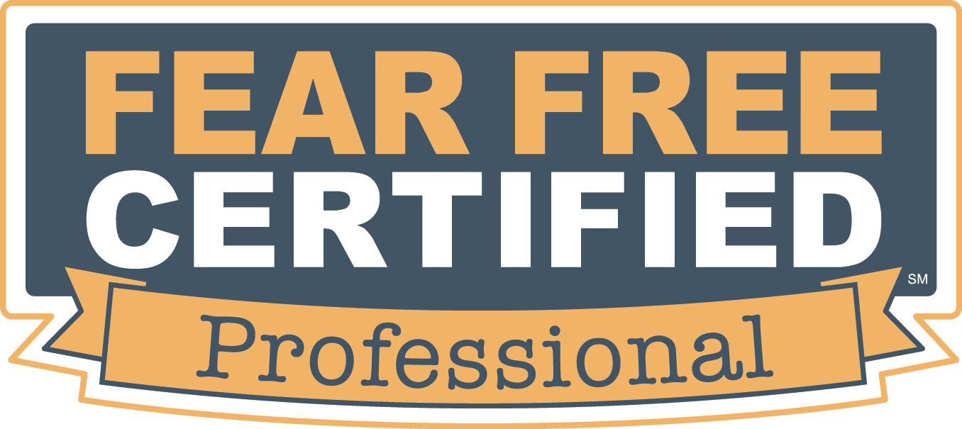
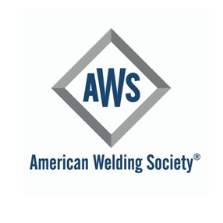
14 Certifications in Welding Technology
WCCC- Calais, Maine
Bachelor in Fine Arts
Hunter College- NYC, NY
Photography
Pratt Institute – Brooklyn, NY
Highschool Diploma
NYC iSchool- NYC, NY

*References available upon request

